Contemplation and Conversation: World Communion Sunday, October 4, 2026
Scripture – Psalm 19 NRSVUE
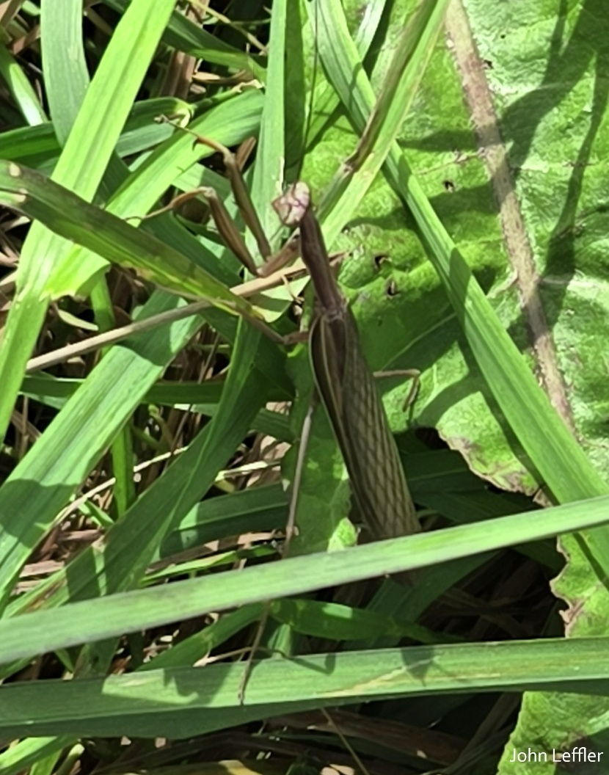
¹ The heavens are telling the glory of God,
and the firmament^{[a]} proclaims his handiwork.
² Day to day pours forth speech,
and night to night declares knowledge.
³ There is no speech, nor are there words;
their voice is not heard;
⁴ yet their voice^{[b]} goes out through all the earth
and their words to the end of the world.
In the heavens^{[c]} he has set a tent for the sun,
⁵ which comes out like a bridegroom from his wedding canopy,
and like a strong man runs its course with joy.
⁶ Its rising is from the end of the heavens
and its circuit to the end of them,
and nothing is hid from its heat.
⁷ The law of the Lord is perfect,
reviving the soul;
the decrees of the Lord are sure,
making wise the simple;
⁸ the precepts of the Lord are right,
rejoicing the heart;
the commandment of the Lord is clear,
enlightening the eyes;
⁹ the fear of the Lord is pure,
enduring forever;
the ordinances of the Lord are true
and righteous altogether.
¹⁰ More to be desired are they than gold,
even much fine gold;
sweeter also than honey
and drippings of the honeycomb.
¹¹ Moreover, by them is your servant warned;
in keeping them there is great reward.
¹² But who can detect one’s own errors?
Clear me from hidden faults.
¹³ Keep back your servant also from the insolent;^{[d]}
do not let them have dominion over me.
Then I shall be blameless
and innocent of great transgression.
¹⁴ Let the words of my mouth and the meditation of my heart
be acceptable to you,
O Lord, my rock and my redeemer.
From Brian Mack
The praying mantis is not something that I have ever thought about. When John Leffler was working in his garden at my place this week, he took the picture that accompanies this commentary. After reading the first six verses of Psalm 19, the image of the praying mantis that he forwarded to me kept coming back to me and I found myself googling “praying mantis”. They are fascinating creatures that are efficient predators that feast on wasps, spiders, grasshoppers, crickets, and bumblebees. With a triangular head, large compound eyes, and folded raptorial like front legs that appear to be praying, they have often been feared out of ignorance and superstition.
Psalm 19, a song of praise written by King David, reminds us that God is made known to us through the beauty and intricacies of nature as well as through written scripture. Perhaps the late theologian Henri Nouwen expressed it best about when he wrote: “While it is true that God is a hidden presence, we have only to let nature speak to us about the God who is everywhere.” (excerpt from The Genesee Diary).
The next time you look out your kitchen window at a manicured flower bed, take a drive along a country road and admire a golden soybean field, or go for a walk and listen carefully to the buzz of insects or the warbling of birds, consider that nature is God’s gift to us. In response to this gift, begin by remembering that all of the world was created with love and given to us to treasure and care for throughout the ages. Think about what the flora and fauna that surrounds us teaches us about birth, growth, fulfilment, and ultimately death. As you ponder the natural world around you, even in the form of a 10 cm long praying mantis, take time to give God all honor, praise, and glory. Thanks be to God.
Contemplation and Conversation
What is one thing that your engagement with nature has taught you about how to create God’s kingdom (kin-dom) here on earth?
Prayer
Creator God, we give you thanks for the words of King David as to how your will is revealed to us.
Help us to discern the great story of your love
by observing the work of your hands that is all around us.
May we be open to a richer view of your intentions for us through the natural environment. Amen.

Further Conversation … We would love to hear from you! Please consider sharing your thoughts on the Contemplation and Conversation question on our Rockwood Stone Facebook Page.

Our Rockwood Stone Family
If you missed today’s worship service, you can watch it here: https://youtu.be/qJBjZ9Ap8Mg

United Church of Canada
On Sisters in Spirit Day, we remember and honour Missing and Murdered Indigenous Women, Girls, and 2SLGBTQI+ people. We remember them for how they lived, the people they loved, and the lives they should still be living.
We stand with survivors, families, and communities whose courage, leadership, and advocacy continue to call us toward justice and accountability. Together, we recommit ourselves to ending this violence and ensuring their stories are never forgotten.
National IRS Crisis Line 1-866-925-4419 | MMIWG Crisis Line 1-844-413-6649
#UCCan #SistersInSpirit #MMIWG2S
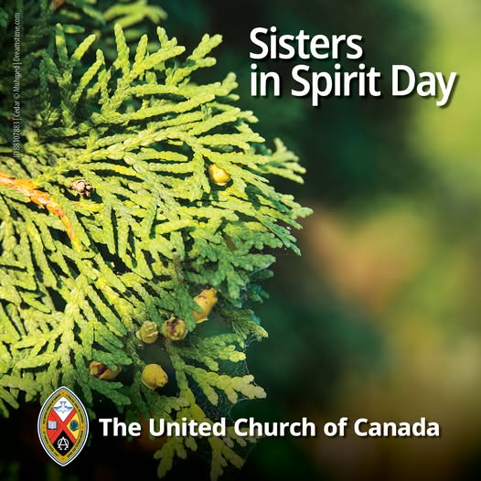

A gift of belonging to a church is that the practice of gathering together for worship … to pray, sing, listen to scripture and share how God touches our lives – helps us grow in deeper relationship with God and each other. We are offering this practice of sharing beyond Sunday morning to deepen our connection. Each week you are offered a picture, a scripture and a question for contemplation, as well as a short reflection for you to contemplate, have conversation with people in your life and/or join an online conversation on our Rockwood Stone Facebook page.
Go to https://www.rockwoodstoneunitedchurches.com/ learn more about our churches.

