Contemplation and Conversation: 14th Sunday after Pentecost, August 30, 2026
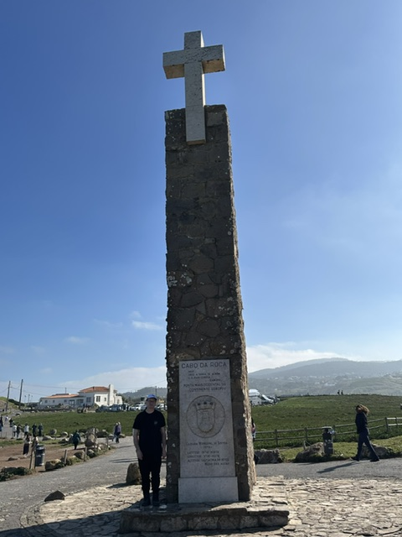
Scripture – Matthew 16:21-28 NRSVUE
²¹ From that time on Jesus began to explain to his disciples that he must go to Jerusalem and suffer many things at the hands of the elders, the chief priests and the teachers of the law, and that he must be killed and on the third day be raised to life.
²² Peter took him aside and began to rebuke him. “Never, Lord!” he said. “This shall never happen to you!”
²³ Jesus turned and said to Peter, “Get behind me, Satan! You are a stumbling block to me; you do not have in mind the concerns of God, but merely human concerns.”
²⁴ Then Jesus said to his disciples, “Whoever wants to be my disciple must deny themselves and take up their cross and follow me. ²⁵ For whoever wants to save their life[a] will lose it, but whoever loses their life for me will find it. ²⁶ What good will it be for someone to gain the whole world, yet forfeit their soul? Or what can anyone give in exchange for their soul? ²⁷ For the Son of Man is going to come in his Father’s glory with his angels, and then he will reward each person according to what they have done.
²⁸ “Truly I tell you, some who are standing here will not taste death before they see the Son of Man coming in his kingdom.”
From Liz Guthrie
In this reading, we find that Jesus is preparing the disciples for all the events leading up to and including his death. Peter has trouble accepting the fact that Jesus has to face denial, beatings and death on the cross.
Jesus words, “take up their cross” really popped out for me. How do I take up the cross ? How do you take up the cross? In the hymn “Take up Your Cross”, Charles William Everest wrote about a willing heart that will bear the weight of the cross because Christ will bear us up. Don’t be ashamed or let pride get in the way of bearing a cross.
Mother Teresa, a teacher and missionary, certainly bore a cross as she begged for food, clothing and medical care for the very poor in Calcutta.Even though she led a hard, frustrating and lonely life she did not give up.
How do I take up my cross? I’ve offered housing to children and grandchildren. I volunteer for church committees and take out dinners. I help to make apple dumplings at Erin Fair.
There are so many other ways of taking up your cross. Perhaps, it is paying it forward, getting groceries for a shut in or providing a ride to an appointment or pet sitting or…
The scripture says we will be rewarded for what we have done. I think the biggest reward is the satisfaction of helping wherever and whenever we can.
Contemplation and Conversation
What cross have you taken up? What skill or hobby are you using when reaching out to others?
Prayer
Caring God, thank you for Jesus who bore the cross for us. He showed us how to bear not only our crosses but how to reach out with willing hearts and hands to help others in times of need. May our actions show that there are still good things happening in this world. Amen.

Further Conversation … We would love to hear from you! Please consider sharing your thoughts on the Contemplation and Conversation question on our Rockwood Stone Facebook Page.

Our Rockwood Stone Family
If you missed today’s worship service, you can watch it here: https://youtu.be/u0iB13CZDxg .

United Church of Canada
A Prayer for Harm Reduction Sunday: This Harm Reduction Sunday, August 30, 2026 we invite you to consider how your community of faith, through small and faith-filled actions, could cultivate a world where life can be better for those whose lives are so often held precariously.
God of the cross,
You who call us into active presence and participation,
Be present as we consider the ways you challenged us to live lives worthy of your purpose.
Be present as we recognize the wounds inflicted on members of our community.
Be present as you call us to act with integrity and hope in response to the systems of neglect, stigma, and isolation.
For we know, the toxic drug crisis continues to claim the lives of neighbours, friends, family and community members,
For we know, the toxic drug crisis is volatile and reaches across the globe.
For we know, that every life lost is another story cut short by the crucifixions of our world.
Challenge us
Enliven us.
Call us.
Amen
—The Rev. Jeffrey Dale, MFA, M Div is minister at College Street United Church.
#UCCan #HarmReduction #HarmReductionSunday
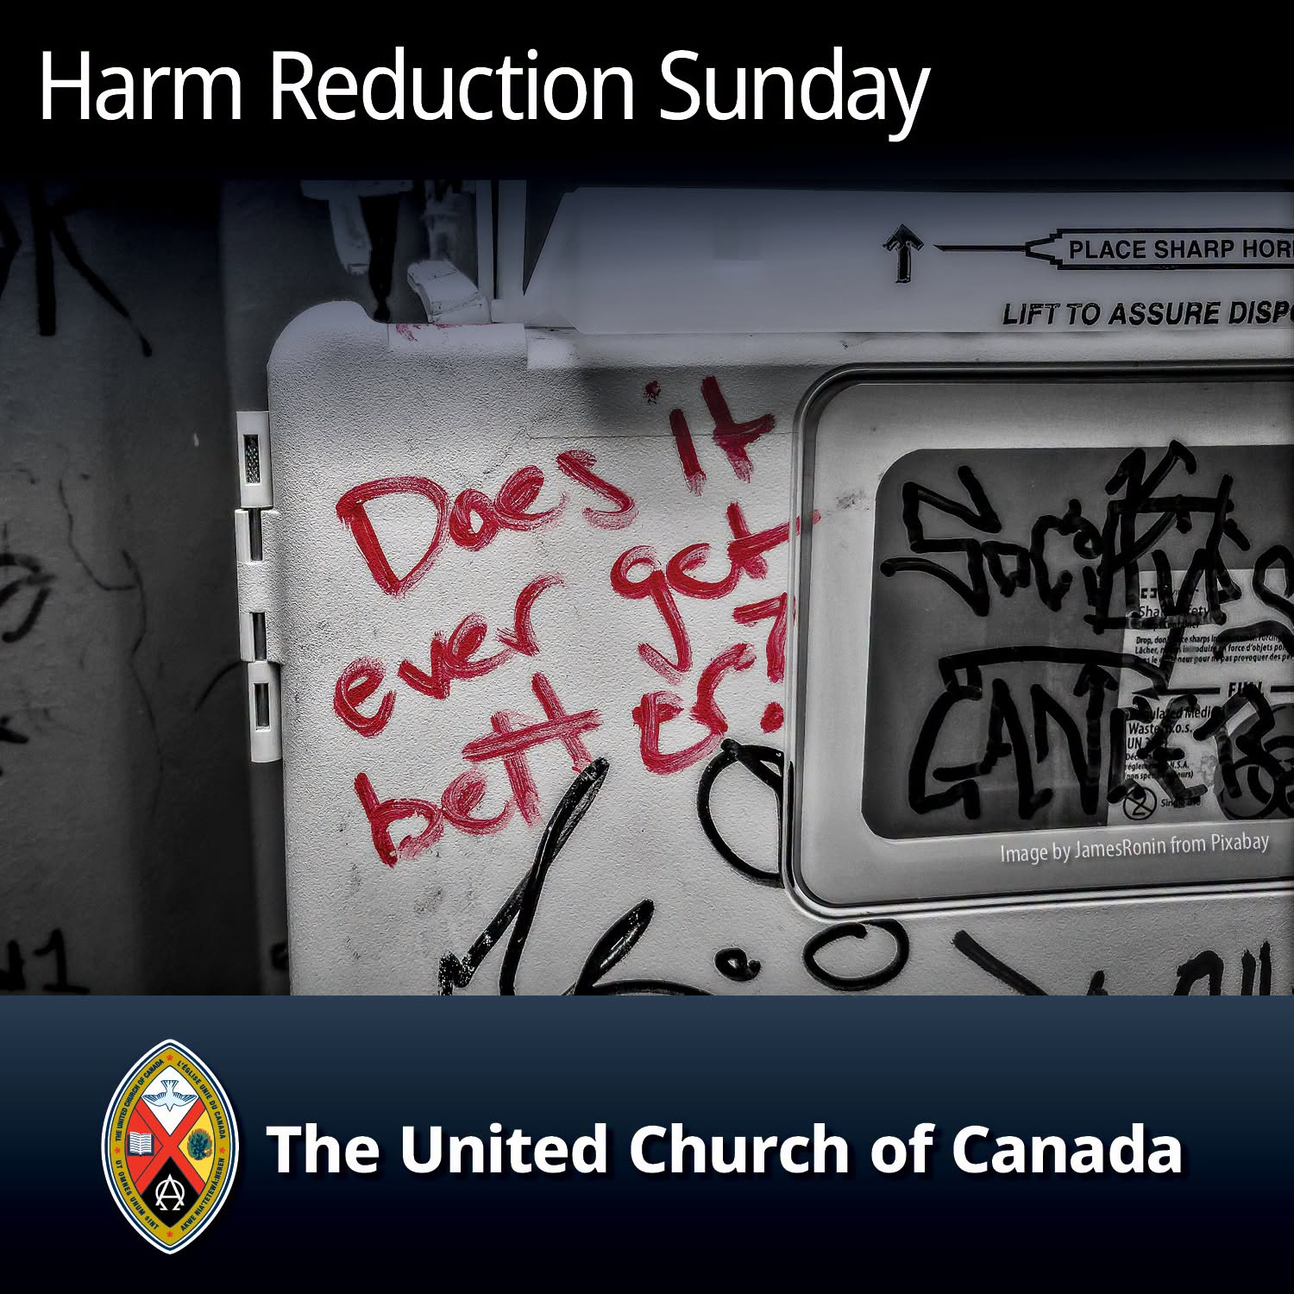

A gift of belonging to a church is that the practice of gathering together for worship … to pray, sing, listen to scripture and share how God touches our lives – helps us grow in deeper relationship with God and each other. We are offering this practice of sharing beyond Sunday morning to deepen our connection. Each week you are offered a picture, a scripture and a question for contemplation, as well as a short reflection for you to contemplate, have conversation with people in your life and/or join an online conversation on our Rockwood Stone Facebook page.
Go to https://www.rockwoodstoneunitedchurches.com/ learn more about our churches.

