Contemplation and Conversation: 13th Sunday after Pentecost, August 23, 2026
Scripture – Romans 12: 1-8 NLV
Christian brothers, I ask you from my heart to give your bodies to God because of His loving-kindness to us. Let your bodies be a living and holy gift given to God. He is pleased with this kind of gift. This is the true worship that you should give Him. ² Do not act like the sinful people of the world. Let God change your life. First of all, let Him give you a new mind. Then you will know what God wants you to do. And the things you do will be good and pleasing and perfect.
³ God has given me His loving-favor. This helps me write these things to you. I ask each one of you not to think more of himself than he should think. Instead, think in the right way toward yourself by the faith God has given you. ⁴ Our bodies are made up of many parts. None of these parts have the same use. ⁵ There are many people who belong to Christ. And yet, we are one body which is Christ’s. We are all different but we depend on each other. ⁶ We all have different gifts that God has given to us by His loving-favor. We are to use them. If someone has the gift of preaching the Good News, he should preach. He should use the faith God has given him. ⁷ If someone has the gift of helping others, then he should help. If someone has the gift of teaching, he should teach. ⁸ If someone has the gift of speaking words of comfort and help, he should speak. If someone has the gift of sharing what he has, he should give from a willing heart. If someone has the gift of leading other people, he should lead them. If someone has the gift of showing kindness to others, he should be happy as he does it.
From Tammy Smits
I am sure I am not alone in scrolling a social media platform of choice, looking at the posts of people who are more fit than me, who have better gardens than mine, who have taken more interesting vacations, have more thoughtful opinions on world matters, and generally seem to have their ducks in a row much tidier than mine.
Paul sends a reminder that we are all joined together similar to how individual parts of a body make a whole, and as such we all have different gifts to share. Fingers don’t hear well, toes don’t see much, and knees stink at smelling things (pun intended). God may not have fashioned me as a fitness guru, master gardener, travel expert or political philosopher. But I am blessed with other talents.
We all need to stop trying to be what we aren’t and comparing ourselves to others, and instead learn to recognize, hone and celebrate our unique gifts and how they can be used to serve ourselves, others and God. And maybe we could cut back on the social media scrolling while we are at it.
Contemplation and Conversation
What unique gifts to you have that you can celebrate?
Prayer
Dear Lord, help me to recognize and appreciate
the gifts you have so graciously given me,
and to learn use them wisely and effectively.
Amen.

Further Conversation … We would love to hear from you! Please consider sharing your thoughts on the Contemplation and Conversation question on our Rockwood Stone Facebook Page.

Our Rockwood Stone Family
If you missed today’s worship service, you can watch it here: https://youtu.be/zUDGaxdiRlg

United Church of Canada
Looking for the latest news from The United Church of Canada?
E-ssentials delivers essential updates on events, campaigns, social action, worship resources, and more—every week.
Subscribe to E-ssentials:
https://united-church.us3.list-manage.com/subscribe...
Read the latest issue:
https://mailchi.mp/united-church/e-ssentials-4755880
Stay informed, inspired, and connected! 

With sadness and concern, we have learned of the violent attack at Nanaksar Gurdwara in Edmonton, where two members of the Sikh community were injured while gathered in worship and prayer. We hold the victims, their loved ones, and the entire Sikh community in our prayers as they seek healing and comfort in the days ahead.
Places of worship are sacred spaces. They are meant to be places of refuge, peace, and belonging, where people gather to pray, seek spiritual nourishment, and experience community. The vice-president Zora Grewal, reminded us that the temple's doors are open to all, that it is a place for prayer and peace of mind, and that its community seeks to respond not with hatred, but with love.
As followers of Christ, we remain in solidarity with our Sikh siblings and with all who have been shaken by this act of violence. We join in the prayer that such harm will not happen again and reaffirm our shared commitment to communities where every person can worship in safety, dignity, and peace.
May God's healing presence surround those who were injured, bring strength to the Nanaksar Gurdwara community, and inspire all of us to be courageous builders of peace, understanding, and compassionate neighbourliness. 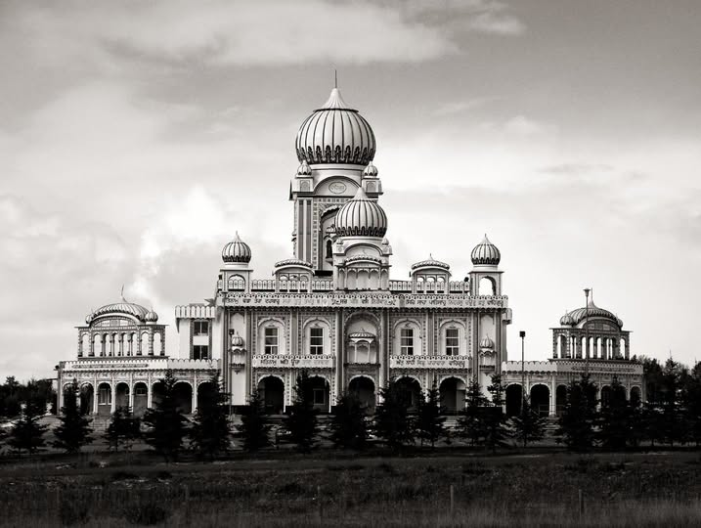
Photo: Nanaksar Gurdwara Sihk Temple on Horsehills Road in Edmonton Alberta Canada. Photo Credit: Darren Kirkby

A gift of belonging to a church is that the practice of gathering together for worship … to pray, sing, listen to scripture and share how God touches our lives – helps us grow in deeper relationship with God and each other. We are offering this practice of sharing beyond Sunday morning to deepen our connection. Each week you are offered a picture, a scripture and a question for contemplation, as well as a short reflection for you to contemplate, have conversation with people in your life and/or join an online conversation on our Rockwood Stone Facebook page.
Go to https://www.rockwoodstoneunitedchurches.com/ learn more about our churches.

