Contemplation and Conversation: 11th Sunday after Pentecost, August 9, 2026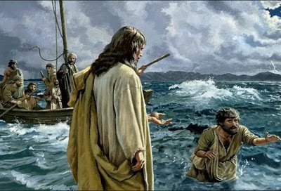
This Photo by Unknown Author is licensed under CC BY-NC-ND
Scripture – Matthew 14: 22-23 NRSVUE
²² Immediately he made the disciples get into a boat and go on ahead to the other side, while he dismissed the crowds. ²³ And after he had dismissed the crowds, he went up the mountain by himself to pray. When evening came, he was there alone, ²⁴ but by this time the boat, battered by the waves, was far from the land, for the wind was against them. ²⁵ And early in the morning he came walking toward them on the sea. ²⁶ But when the disciples saw him walking on the sea, they were terrified, saying, “It is a ghost!” And they cried out in fear. ²⁷ But immediately Jesus spoke to them and said, “Take heart, it is I; do not be afraid.”
²⁸ Peter answered him, “Lord, if it is you, command me to come to you on the water.” ²⁹ He said, “Come.” So Peter got out of the boat, started walking on the water, and came toward Jesus. ³⁰ But when he noticed the strong wind, he became frightened, and, beginning to sink, he cried out, “Lord, save me!” ³¹ Jesus immediately reached out his hand and caught him, saying to him, “You of little faith, why did you doubt?” ³² When they got into the boat, the wind ceased. ³³ And those in the boat worshiped him, saying, “Truly you are the Son of God.”
From Barb Parker
The biblical account of Jesus walking on water is recorded in the Gospels of Matthew, Mark, and John. It takes place in the evening/early morning, after the miracle of the “feeding of the 5000”. Jesus instructs the disciples to get into a boat and go to the other side of the lake, while he goes alone, up the mountain to pray. During the night a violent storm pushes the disciple’s boat far from land. Early in the morning, the disciples see a shadowy figure walking on the water, towards them. They cry out in fear, terrified it is a ghost. Jesus’s voice calms them and tells them to not be afraid. Peter, the ever-impulsive disciple, asks Jesus to command him to come to Jesus on the water. We all know what happens next … Peter starts out confident and trusting in Jesus, only to be overwhelmed by the wind and waves, and starts to sink, as doubt sets in. Jesus immediately holds out his hand to Peter, asking him (perhaps rebuking him in frustration? Maybe in a chastising tone?) in the words we have all heard many times, “You of little faith, why did you doubt?” We don’t get to hear Peter’s response, but clearly this episode, the second significant miracle in just a few hours, has deeply impacted all of the disciples. As the waters calm, they worship Jesus, saying “Truly, you are the Son of God”.
You may have seen Peter’s experience, somewhat lived out in your children or grandchildren, learning to float… all goes well when they start off relaxed, head back, and a parent or lifeguard is near, but in just a few feet, doubt and fear can set in, and the flailing starts, and they reach out for a trusted near-by hand. This scripture also reminds me of times when a new or important event I have helped organize ends up going smoothly or being more successful than I expected… and I have said to myself “O me of little faith”. I think though, perhaps the phrase “walking on water” has become more colloquial than biblical in this day and age.
This scripture, with its image of Jesus calmly holding out his hand to Peter, and the background of wild seas and winds, has inspired several works of art, including the one pictured above. The hymn “Will Your Anchor Hold” is based on a similar theme, with its references to storms of life, the tempests rave, and the wild winds blow. The chorus reminds us that Jesus and his love are the anchor that keeps us steadfast. The scripture confirms Jesus is present in life’s storms, ready to save and provide comfort. And yes, we can consider stepping out of our comfort zone, with the sure knowledge that there are many hands to help, if we are open to it.
Contemplation and Conversation
Have you had life experiences which challenged your faith or caused times of doubt?
Prayer
Lord, we ask for your strong hand and calming presence when life is hard.
We listen for your voice to guide us, in times of doubt. Thankyou for being our anchor. Amen.

Further Conversation … We would love to hear from you! Please consider sharing your thoughts on the Contemplation and Conversation question on our Rockwood Stone Facebook Page.

Our Rockwood Stone Family
If you missed today’s worship service, visit our https://youtu.be/8Lc4-RCy3Mk

United Church of Canada
River Run 2026: Walk with Grassy Narrows for Mercury Justice
Churches invited to raise their voices on September 23 in solidarity with the community devastated by mercury poisoning for six decades
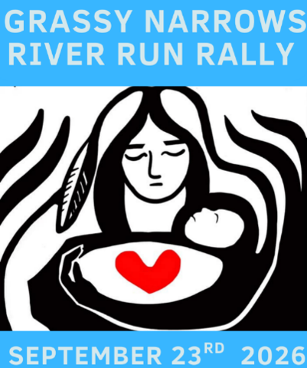
Credit: Grassy Narrows River Run
Published On: July 31, 2026
The devastating mercury crisis in Grassy Narrows First Nation has persisted for decades, ever since 9 tonnes of mercury was dumped upstream from the community in the 1960s, with little action since from governments to help the people.
To this day, most Grassy Narrows members get no compensation for the serious impacts of the ongoing mercury crisis on their health, culture, and livelihoods. To make matters worse, Ontario is still allowing mining exploration on Grassy Narrows lands—against Grassy Narrows’ will.
The United Church of Canada officially endorses the Grassy Narrows River Run(opens in a new tab). The Indigenous Ministries and Justice and the Climate Justice staff team are working collaboratively to support the grassroots organizers of the River Run. We invite all United Church folks across Turtle Island to join them on their path to achieve mercury justice and freedom!
You can support directly by amplifying Grassy Narrows’(opens in a new tab) social media posts(opens in a new tab). You can also invite your community of faith, family, and friends to join the United Church contingent of the Grassy Narrows River Run at Grange Park in downtown Toronto at noon on September 23, 2026. We will have a big banner!
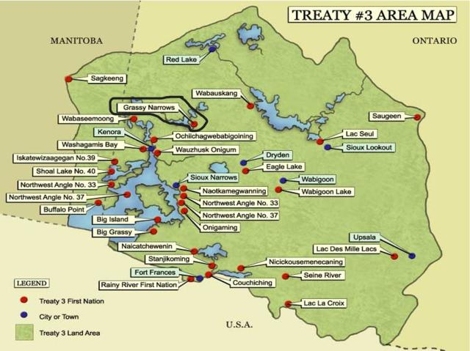
Credit: Grassy Narrows River Run
How Communities of Faith Can Support the River Run
- Amplify the River Run through your social media networks and community bulletins.
- On Sunday, September 20, please offer this Prayer for Grassy Narrows during your worship service to keep the youth, Elders, and community of Grassy Narrows in our hearts and wish them a safe journey to Toronto.
- Ring your church bells at 1 pm ET on September 23, in solidarity with the River Run and to take a stand against mercury and environmental poisoning.
- Walk this journey together in unity. The walk is anticipated to begin at 12 pm ET at Grange Park, and arrive at Queen’s Park by 3 pm ET. Meet at 11:45 near the Henry Moore Sculpture(opens in a new tab) so we can walk together—keep your eye out for The United Church of Canada banner. If you plan to attend, please contact us directly by emailing , and RSVP at the Grassy Narrows RSVP link(opens in a new tab).
- If you are outside Toronto, reserve a seat on one of the buses departing from regional centres, including: Hamilton(opens in a new tab), St. Catherine’s(opens in a new tab), Kingston,(opens in a new tab) Guelph(opens in a new tab), Kitchener and Waterloo(opens in a new tab), London(opens in a new tab), Peterborough(opens in a new tab), Barrie, and Orillia.
- If you are unable to join us, you can also support Grassy Narrows River Run by donating(opens in a new tab).
- Advocate with Grassy Narrows by signing and promoting this petition(opens in a new tab) to the Prime Minister and the Premier of Ontario.
To learn more about the River Run, please visit the Free Grassy Narrows website(opens in a new tab).
Background
Grassy Narrows people are powerful leaders in the movement for Indigenous sovereignty and environmental justice. They have shown us that we can fight for justice against all odds and make real gains.
Together, Grassy Narrows people have kicked the world’s largest newsprint company off Grassy Narrows lands, forced the government to commit to clean up the English and Wabigoon Rivers, comprehensively reformed the Mercury Disability Board, and built a Mercury Care Home and Treatment Centre in Grassy Narrows.
They won’t stop until Grassy Narrows has the good life that they enjoyed before mercury.
Come out to show your support for Grassy Narrows’ fight for mercury justice at the River Run on September 23! Community members and leaders will travel 1,700 kilometers from Grassy Narrows to Toronto to demand that Ontario and Canada:
- Compensate everyone in Grassy Narrows fairly for the mercury crisis.
- End the pollution by stopping the Dryden Mill, and ending mining and nuclear waste plans that threaten Grassy Narrows.
- Support Grassy Narrows in restoring their community and way of life from the damage that mercury has done.
In April 2026, The Right Rev. Dr. Kimberly Heath, Moderator urged the Prime Minister to apologize to Grassy Narrows and echoed Grassy Narrows’ demands for fair compensation for harm of mercury poisoning, and an end to Dryden Mill’s ongoing pollution.
For more resources to support Grassy Narrows, explore the River Run Rally Action Toolkit(opens in a new tab).

A gift of belonging to a church is that the practice of gathering together for worship … to pray, sing, listen to scripture and share how God touches our lives – helps us grow in deeper relationship with God and each other. We are offering this practice of sharing beyond Sunday morning to deepen our connection. Each week you are offered a picture, a scripture and a question for contemplation, as well as a short reflection for you to contemplate, have conversation with people in your life and/or join an online conversation on our Rockwood Stone Facebook page.
Go to https://www.rockwoodstoneunitedchurches.com/ learn more about our churches.

