Contemplation and Conversation: 7th Sunday after Pentecost, July 12, 2026
Scripture – Matthew 13:1-9, 18-23 NIV
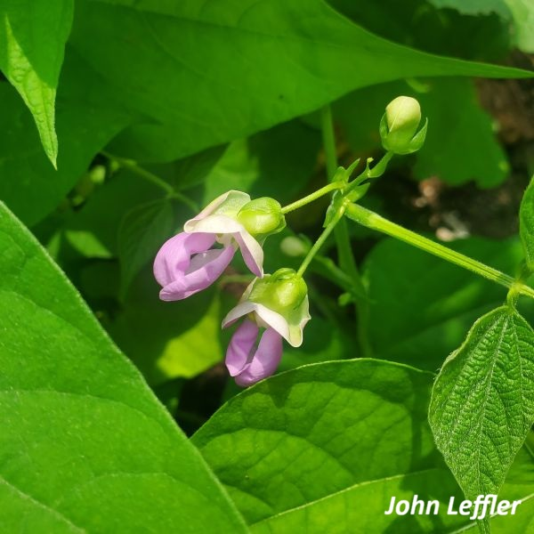
13 That same day Jesus went out of the house and sat by the lake. ² Such large crowds gathered around him that he got into a boat and sat in it, while all the people stood on the shore. ³ Then he told them many things in parables, saying: “A farmer went out to sow his seed. ⁴ As he was scattering the seed, some fell along the path, and the birds came and ate it up. ⁵ Some fell on rocky places, where it did not have much soil. It sprang up quickly, because the soil was shallow. ⁶ But when the sun came up, the plants were scorched, and they withered because they had no root. ⁷ Other seed fell among thorns, which grew up and choked the plants. ⁸ Still other seed fell on good soil, where it produced a crop—a hundred, sixty or thirty times what was sown. ⁹ Whoever has ears, let them hear.”
¹⁸ “Listen then to what the parable of the sower means: ¹⁹ When anyone hears the message about the kingdom and does not understand it, the evil one comes and snatches away what was sown in their heart. This is the seed sown along the path. ²⁰ The seed falling on rocky ground refers to someone who hears the word and at once receives it with joy. ²¹ But since they have no root, they last only a short time. When trouble or persecution comes because of the word, they quickly fall away. ²² The seed falling among the thorns refers to someone who hears the word, but the worries of this life and the deceitfulness of wealth choke the word, making it unfruitful. ²³ But the seed falling on good soil refers to someone who hears the word and understands it. This is the one who produces a crop, yielding a hundred, sixty or thirty times what was sown.”
From Tammy Smits
Perhaps it is because I have been spending a lot of time in my gardens these days that moved me to choose this passage. The Parable of the Sower is a familiar one - the seeds sown on the side of the path are those who hear the message but don’t understand, the seeds on rocky soil receive the message but abandon it when trouble arrives, the seeds sown in the bushes are choked out by everyday worries, and the seeds sown in good soil hear, understand and bear fruit.
As a relatively novice gardener, I am trying to learn how to grow plants, both flowers and vegetables, well. My Facebook feed is full of “co-planting hacks” with an overwhelming amount of suggestions on what to plant to support soil health, attract pollinators, deter pests and produce healthy plants. Different plants have different needs and provide different benefits.
Then I remembered the Indigenous practice of the “3 Sisters”, where corn, beans and squash are planted together - the corn is a trellis for the beans, the beans nourish the soil, and the squash suppress weeds and retain moisture.
Like plants, people have different needs, flourish in different environments and provide different benefits. Perhaps if we are seeds sown by God, we are sown to help each other flourish.
Maybe you are a squash who can choke out someone else’s worries and fears. Maybe you are a corn, who can give someone a lift when needed. Maybe you are a bean, who can feed and nourish others, be it physically or spiritually.
Sadly, despite our best efforts as gardeners, not every seed germinates and not every plant bears fruit; but as seeds of the spirit, we can help those around us to achieve their maximum potential with God’s love and sunshine fueling the process.
Contemplation and Conversation
What do you need to flourish? How can you help others flourish?
Prayer
Dear Lord, thank you for fueling us to support each other,
recognizing our differences can be mutually beneficial instead of competitive.
Help us to thrive through togetherness. Amen.

Further Conversation … We would love to hear from you! Please consider sharing your thoughts on the Contemplation and Conversation question on our Rockwood Stone Facebook Page.

Our Rockwood Stone Family
If you missed today’s worship service, you can watch it here: https://youtu.be/WKU-BlnWchs

United Church of Canada
Refugee Claimants in Canada Deserve Full Protection
Raise your voice as the government denies hearings for asylum seekers, placing many at grave risk 
Voices across The United Church of Canada are raising concerns about the recently implemented Bill C-12, for the risk of serious harm it puts many refugee claimants in. Introduced by the federal government as the Strengthening Canada's Immigration System and Borders Act, claimants across the country are being denied access to hearings to support their claims for refugee protection, placing them at serious risk of deportation without adequate protection.
Church leaders report that more than 60 asylum seekers, including families with young children, have been denied hearings. Emerging communities of faith across Canada describe widespread fear and uncertainty among their members, many of whom are now facing impossible choices: comply with removal orders, return to danger, or remain undocumented without access to essential supports. Advocates warn that these outcomes increase the likelihood of family separation, children losing caregivers, and heightened vulnerability to exploitation.
For more information, read our news item: United Church Raises Alarm Over Bill C-12 Risks to Refugee Communities in Canada.
Take Action
Grounded in its faith-based commitment to migrant justice and human dignity, The United Church of Canada is calling for the repeal of Bill C-12. Raise your voice with us, and call on your member of parliament to advocate for the action within their caucus!
At minimum, immediate amendments to the bill must be made to ensure that all current applicants have access to a fair hearing, and are protected from removal while their cases are unresolved. Share your perspective on how Canada should be using policy to protect the vulnerable, and not to endanger them.

A gift of belonging to a church is that the practice of gathering together for worship … to pray, sing, listen to scripture and share how God touches our lives – helps us grow in deeper relationship with God and each other. We are offering this practice of sharing beyond Sunday morning to deepen our connection. Each week you are offered a picture, a scripture and a question for contemplation, as well as a short reflection for you to contemplate, have conversation with people in your life and/or join an online conversation on our Rockwood Stone Facebook page.
Go to https://www.rockwoodstoneunitedchurches.com/ learn more about our churches.

