Contemplation and Conversation: Sunday after Pentecost, July 5, 2026

Scripture – Psalm 145 NRSVUE
⁸ The Lord is gracious and merciful,
slow to anger and abounding in steadfast love.
⁹ The Lord is good to all,
and his compassion is over all that he has made.
¹⁰ All your works shall give thanks to you, O Lord,
and all your faithful shall bless you.
¹¹ They shall speak of the glory of your kingdom
and tell of your power,
¹² to make known to all people your^{[b]} mighty deeds
and the glorious splendor of your^{[c]} kingdom.
¹³ Your kingdom is an everlasting kingdom,
and your dominion endures throughout all generations.
The Lord is faithful in all his words
and gracious in all his deeds.^{[d]}
¹⁴ The Lord upholds all who are falling
and raises up all who are bowed down.
From Rosslyn Bentley
Psalm 145 is the final psalm specifically attributed to King David. It serves as a majestic hymn of praise focusing on God’s sovereign majesty, unfailing goodness, and tender compassion. Structurally, it is an acrostic poem where every verse begins with a consecutive letter of the Hebrew alphabet. This is thought to reflect the completeness of God’s love from A to Z literally.
As someone who studied poetry at university (a very long time ago now!) and who loves word play and puzzles, the skill to compose an acrostic poem is always one which inspires awe. David is such a fascinating character in the Bible, so full of skill, gratitude and humility yet also sin, and moral failings – in other words so human. His gratitude and praise always seem embedded in his gift as a musician and poet, a simple shepherd who rises to be a king and who retains the ability to recognise his own failings and to bring them to God with a repentant and contrite heart.
The psalm balances the grand, cosmic power of an everlasting King with deeply intimate, personal care. God lifts up the fallen, satisfies the desires of the hungry, and draws near to those who "call on Him in truth". David not only saved his own life when he stood before the giant warrior Goliath but that of his people. That would indeed be something worthy of inspiring a life long personal and grateful relationship with God.
What inspires you to be grateful for a personal relationship with God? Do you feel you have a personal relationship or is God a distant and ancient figure in your mind? How do you go about praising God? I may not be composing acrostic poems, but I certainly feel singing and making music are ways of bringing praise and gratitude to a special level and something that can be shared and inspire joy.
Contemplation and Conversation
When have you experienced God’s personal presence?
How does this relationship inspire you to provide praise?
Prayer
Lord, you are near to all who call on you in truth. I draw close to You today, asking that You keep my heart pure and my words full of Your praise. Let my life and my mouth declare Your praise to the world and let Your righteousness be known. In Jesus' name, amen.

Further Conversation … We would love to hear your thoughts. Please consider sharing your thoughts on the Contemplation and Conversation question on our Rockwood Stone Facebook Page.

Our Rockwood Stone Family
If you missed today’s worship service, you can watch it here: https://youtu.be/y0lXbaH7tR8
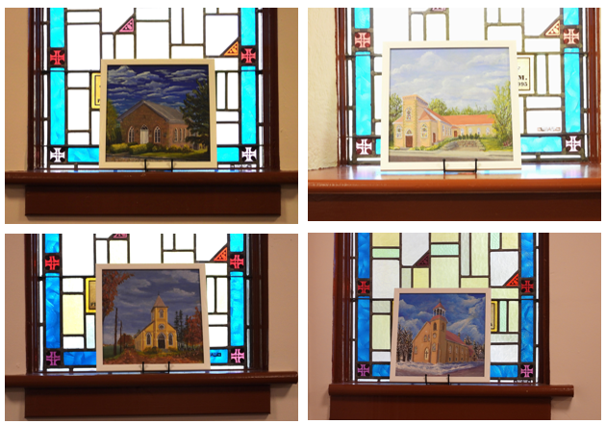
If you would like a closer look at the photos shared in worship last week you can find them here: https://youtu.be/s2TIDgj9xLg
From Rev. Heather Leffler…Thank you so for our time together, for last Sunday’s wonderful celebration and for the precious gifts you gave me to remember Stone and Rockwood, Alsfeldt, and Knox United Churches.

United Church of Canada
Do I Belong in Church?: Shara Cooper writes about her unexpected journey toward discovering a faith of her own—and finding a place to belong at Robertson Wesley United Church in Edmonton.
This reflection invites us to sit with the question "Do I belong in church?" honestly—not as something with a quick answer, but more as something that can open space for healing, memory, doubt, and hope. It speaks to discovering ways of belonging that are often gradual, and sometimes unexpected, developing connection with God and community through story and relationship rather than certainty.
Read the full blog post: https://united-church.ca/.../round-table/do-i-belong-church
[Photo: The author (right) helps her mom celebrate her sister's third birthday (circa 1983)
Credit: Shara Cooper]
#UCCan #FindingFaith
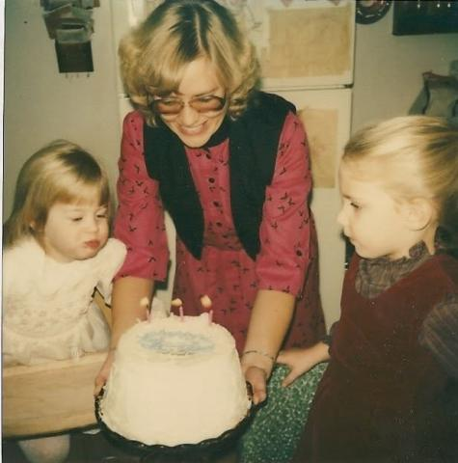
The author (right) helps her mom celebrate her sister's third birthday (circa 1983)
Credit: Shara Cooper

A gift of belonging to a church is that the practice of gathering together for worship … to pray, sing, listen to scripture and share how God touches our lives – helps us grow in deeper relationship with God and each other. We are offering this practice of sharing beyond Sunday morning to deepen our connection. Each week you are offered a picture, a scripture and a question for contemplation, as well as a short reflection for you to contemplate, have conversation with people in your life and/or join an online conversation on our Rockwood Stone Facebook page.
Go to https://www.rockwoodstoneunitedchurches.com/ learn more about our churches.

