Contemplation and Conversation: 5th Sunday after Pentecost, June 28, 2026
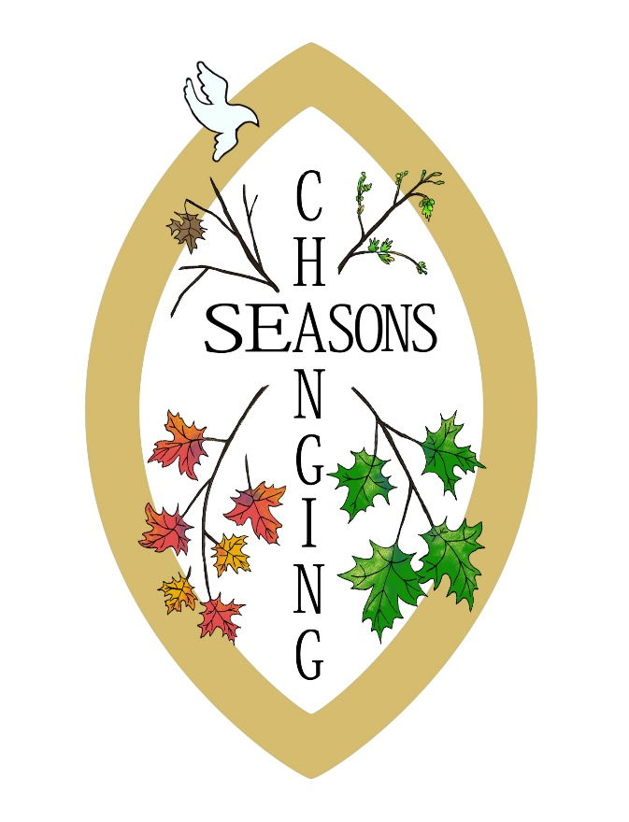
Scripture – Matthew 28:16-20 NRSVUE
¹⁶ Now the eleven disciples went to Galilee, to the mountain to which Jesus had directed them. ¹⁷ When they saw him, they worshiped him, but they doubted. ¹⁸ And Jesus came and said to them, “All authority in heaven and on earth has been given to me. ¹⁹ Go therefore and make disciples of all nations, baptizing them in the name of the Father and of the Son and of the Holy Spirit ²⁰ and teaching them to obey everything that I have commanded you. And remember, I am with you always, to the end of the age.”
From Rev. Heather Leffler
Fourteen years ago the Spirit invited us to journey together for a time. Through those years we have baptized, married, and celebrated the lives of members of our congregation and the community. We have created partnerships so we can learn and grow in faith, feed the hungry, give drink to the thirsty, clothe those in need, heal the sick, and welcome the stranger. It has been a privilege to share in ministry together. I will hold each of you in my heart. Thank you so for our time together, for this Sunday’s wonderful celebration and for the precious gifts you gave me to remember Stone and Rockwood, Alsfeldt, and Knox United Churches.
In the new season ahead, I pray you will continue to engage in deep spiritual, bold discipleship and daring justice. There are people in your communities waiting to be invited into a place of belonging where they are cared for and can care for others and God’s creation – people who long to be accepted as they are and to share their gifts in order to make a difference in the world. In this season, trust that the One who is faithful and whose love is steadfast has chosen you to be a place where others can come to meet the One who is Holy Mystery and Wholly Love.
Just as Jesus commissioned the disciples on the mountain in Galilee, he invites us to be his church. As you continue in ministry, open yourselves to the new possibilities the Spirit has for your congregations and invite others to join you. I will also find new ways to be a disciple in this season of my life. Remember that we are not alone, even when we are apart. God is with us always to the end of the age.
May God continue to bless you as you seek to follow Christ together. Know that I will give thanks for you, remember you with deep affection, and trust that the Spirit will continue to lead you into a hopeful future.
Contemplation and Conversation
What will you carry forward from our time together,
and what will you lovingly leave behind as God leads you into a new season?
Prayer
May God bless you and keep you. May God be gracious to you and shine upon you.
May Christ walk beside you, the Spirit guide you,
and may you always remember that you are not alone.
Go in peace, with courage, hope, and love. Amen.
Further Conversation … Would you like to talk more about today’s reflection? Go to our Facebook page and begin a conversation.

Our Rockwood Stone Family
If you missed today’s worship service, you can watch it here: https://youtu.be/IOW-lkew26Y
Earthquakes in Venezuela where two earthquakes within a minute (7.5 and 7.2 magnitude) with over 500 aftershocks has killed 1,450 people and injured over 3,150 others.
The Canadian Foodgrains Bank is a member of the Humanitarian Coalition that is quickly responding to the need for food and health supplies. The Coalition is able to respond quickly to global crisis such as what happened in Venezuela this week.
If you wish to donate to the Venezuela Relief efforts, you may do so through the Canadian Foodgrains Bank by going to: www.foodgrainsbank.ca/donate/Venezuela/. This much need donation can be sent directly as it is over and above our Foodgrains project.

United Church of Canada from Rev. Dave Jagger
Congregational Stewardship and Generosity
“So long, and thanks for all the fish!”
This is the message left by the dolphins when they departed Planet Earth just before it was demolished in the book by the same title by Douglas Adams.
Now things are not that dire, but this is the last edition of God’s Mission Our Gifts that I will be helping produce.
I will be retiring on June 30 and so will no longer be your Community of Faith Stewardship Team Lead.
As I think about the last 10 years in devoted stewardship work, there are many “fish” to be thankful for.
- First must be the incredible people with whom I have worked. You have taught me much and together I really believe we have made a difference in the future of the United Church. Many of these people will continue to work with you, the Communities of Faith, not just to help build sustainability and nurture generous disciples, but to make you look good while doing it!
- Thank you to the participants in any of the Called to Be the Church: The Journey courses. You have helped us refine those courses for others. Your results have proven that these courses work.
- Thank you to those of you willing to risk trying new things. You know there is danger in risk, but you tried anyways and usually succeeded.
I am grateful for the opportunities this work has brought. As you continue to Inspire, Invite and Thank, building stewardship into the very core of the life of your congregation and its people, I wish you all the very best. Tag!!!
Take care. And remember, God loves you!
Rev. Dave

A gift of belonging to a church is that the practice of gathering together for worship … to pray, sing, listen to scripture and share how God touches our lives – helps us grow in deeper relationship with God and each other. We are offering this practice of sharing beyond Sunday morning to deepen our connection. Each week you are offered a picture, a scripture and a question for contemplation, as well as a short reflection for you to contemplate, have conversation with people in your life and/or join an online conversation on our Rockwood Stone Facebook page.
Go to https://www.rockwoodstoneunitedchurches.com/ learn more about our churches.

