Contemplation and Conversation: Sunday of Pentecost, May 31, 2026
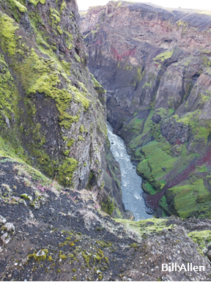
Scripture – Matthew 28:16-20 NRSVUE
¹⁶ Now the eleven disciples went to Galilee, to the mountain to which Jesus had directed them. ¹⁷ When they saw him, they worshiped him, but they doubted. ¹⁸ And Jesus came and said to them, “All authority in heaven and on earth has been given to me. ¹⁹ Go therefore and make disciples of all nations, baptizing them in the name of the Father and of the Son and of the Holy Spirit ²⁰ and teaching them to obey everything that I have commanded you. And remember, I am with you always, to the end of the age.”
From Rev. Heather Leffler
The disciples gathered on a mountain carrying both faith and uncertainty. Matthew tells us that some worshipped and some doubted, yet Jesus entrusted all of them with the same mission. He did not wait until they had all the answers. He simply called them to go, make disciples, teach, baptize, and trust that he would remain with them.
Many generations before us responded to that call in the ways their time required. They built churches, taught children, cared for neighbours, maintained buildings, sang in choirs, served on committees, and gave generously of their time and gifts. Their faithfulness created communities where many of us first encountered God's love. We honour that legacy best not by holding tightly to the forms that served previous generations, but by continuing their willingness to follow where Christ leads today.
The risen Christ still calls us from places of comfort and familiarity into relationships with people who may never have experienced the welcome, hope, and belonging we have found in the church. We are invited to share not only our buildings or programs, but our stories of faith. Like those first disciples, we go carrying both worship and doubt, trusting that Christ is already present wherever we are sent.
Contemplation and Conversation
Who first helped you experience God's love or a sense of belonging in the church,
and how might Christ be inviting you to offer that same gift to someone else today?
Prayer
Loving God, we thank you for the faithful people
who helped us know your love and nurtured this community.
Help us to share that same love,
so others may find hope, welcome, and belonging among us. Amen.

Further Conversation … Would you like to talk more about today’s reflection? Email Heather at hleffler@rogers.com.

Our Rockwood Stone Family
If you missed today’s worship service, you can watch it here: https://youtu.be/hrpK5FVDF04

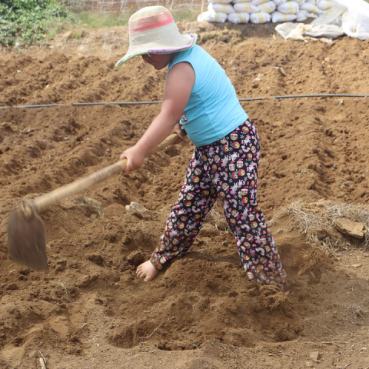
United Church of Canada Published On: April 20, 2026
The Work of Water
In the villages of Am-am and Madalipey in the Philippines, Indigenous families depend on small-scale vegetable farming to support their households. The gardens they tend provide food and a modest income for daily needs.
But over time, the land has changed. As agriculture has expanded, parts of the surrounding forest have been cleared, reducing the land’s ability to hold water. The impacts of climate change have made rainfall patterns less predictable, and dry reasons run longer. For much of the year, local creeks are dry, and water must be brought in from elsewhere. It’s a constant challenge that affects both daily life and the ability to grow crops.
In response, the Cordillera People’s Alliance is working alongside residents to install a solar-powered water pump and storage tank. The system will be maintained locally, ensuring that the community has access to water and ownership of the solution.
With a more stable source of water for both household use and gardens, families can strengthen their livelihoods. Gardens can grow more reliably, daily needs become easier to meet, and pressure on households eases.
When we give through Mission and Service, our gifts are powering long-term support.
Our gifts to Mission and Service help provide stable access to water for Indigenous communities like Am-am and Madalipey. They help sustain life, strengthen food security, and support families as they work toward a more secure future.
Thank you for your gift to Mission and Service.

A gift of belonging to a church is that the practice of gathering together for worship … to pray, sing, listen to scripture and share how God touches our lives – helps us grow in deeper relationship with God and each other. We are offering this practice of sharing beyond Sunday morning to deepen our connection. Each week you are offered a picture, a scripture and a question for contemplation, as well as a short reflection for you to contemplate, have conversation with people in your life and/or join an online conversation on our Rockwood Stone Facebook page.

