Contemplation and Conversation: Pentecost Sunday, May 24, 2026
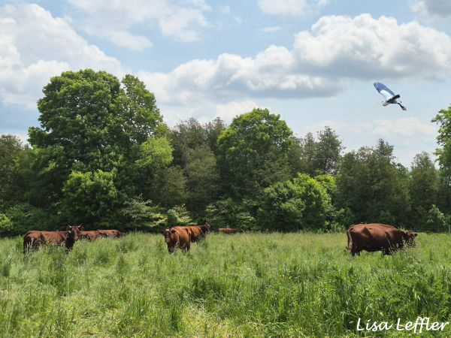
Scripture – Psalm 104 NRSVUE
¹ Bless the Lord, O my soul.
O Lord my God, you are very great.
You are clothed with honor and majesty,
² wrapped in light as with a garment.
You stretch out the heavens like a tent;
³ you set the beams of your^{[a]} chambers on the waters;
you make the clouds your^{[b]} chariot;
you ride on the wings of the wind;
⁴ you make the winds your^{[c]} messengers,
fire and flame your^{[d]} ministers.
⁵ You set the earth on its foundations,
so that it shall never be shaken.
⁶ You cover it with the deep as with a garment;
the waters stood above the mountains.
⁷ At your rebuke they flee;
at the sound of your thunder they take to flight.
⁸ They rose up to the mountains, ran down to the valleys,
to the place that you appointed for them.
⁹ You set a boundary that they may not pass,
so that they might not again cover the earth.
¹⁰ You make springs gush forth in the valleys;
they flow between the hills,
¹¹ giving drink to every wild animal;
the wild asses quench their thirst.
¹² By the streams^{[e]} the birds of the air have their habitation;
they sing among the branches.
¹³ From your lofty abode you water the mountains;
the earth is satisfied with the fruit of your work.
¹⁴ You cause the grass to grow for the cattle
and plants for people to cultivate,
to bring forth food from the earth
¹⁵ and wine to gladden the human heart,
oil to make the face shine
and bread to strengthen the human heart.
¹⁶ The trees of the field^{[f]} are watered abundantly,
the cedars of Lebanon that he planted.
¹⁷ In them the birds build their nests;
the stork has its home in the fir trees.
¹⁸ The high mountains are for the wild goats;
the rocks are a refuge for the coneys.
¹⁹ You have made the moon to mark the seasons;
the sun knows its time for setting.
²⁰ You make darkness, and it is night,
when all the animals of the forest come creeping out.
²¹ The young lions roar for their prey,
seeking their food from God.
²² When the sun rises, they withdraw
and lie down in their dens.
²³ People go out to their work
and to their labor until the evening.
²⁴ O Lord, how manifold are your works!
In wisdom you have made them all;
the earth is full of your creatures.
²⁵ There is the sea, great and wide;
creeping things innumerable are there,
living things both small and great.
²⁶ There go the ships
and Leviathan that you formed to sport in it.
²⁷ These all look to you
to give them their food in due season;
²⁸ when you give to them, they gather it up;
when you open your hand, they are filled with good things.
²⁹ When you hide your face, they are dismayed;
when you take away their breath, they die
and return to their dust.
³⁰ When you send forth your spirit,^{[g]} they are created,
and you renew the face of the ground.
³¹ May the glory of the Lord endure forever;
may the Lord rejoice in his works—
³² who looks on the earth and it trembles,
who touches the mountains and they smoke.
³³ I will sing to the Lord as long as I live;
I will sing praise to my God while I have being.
³⁴ May my meditation be pleasing to him,
for I rejoice in the Lord.
³⁵ Let sinners be consumed from the earth,
and let the wicked be no more.
Bless the Lord, O my soul.
Praise the Lord!
From Brian Mack
Whenever I take a walk on my farm, I am acutely aware of God’s handiwork. The words of the psalmist helped me to see things through a new lens this week. I started one of my excursions in the swampy area near the road. As I paused for a few minutes, I was struck by the beauty of a great blue heron standing amidst a sea of buttercups. I found myself quietly singing the words of “All Things Bright and Beautiful” and “This is God’s Wondrous World”. The words of the psalmist had triggered in me a reminder of God as Creator. I offered this simple prayer: “Creator God, I stand in awe at your many works. I acknowledge your wisdom and power in creating the world and all living things. Amen”
As I continued on my walk, I crossed a lazily flowing stream that has as its source an ever-bubbling spring. In the meadow on the other side of the creek, mice scurried under my feet seeking seeds left from last year, robins chirped with delight when they secured a worm, and a fox barked in the distance. I found myself singing the words of “God of the Sparrow”. The words of the psalmist had triggered in me a reminder of God as Sustainer. I offered this humble prayer: “Sustaining God, I acknowledge that all life depends on you for sustenance and renewal. Help me to be more aware of the interdependence of all creatures and all habitats. Amen”
Finally, I sat down on an old tree stump in my bush. All was quiet. As I closed my eyes, the following line of psalm 104 kept replaying in my mind: “You send forth your Spirit, and they are created; and you renew the face of the earth.” I found myself singing the words of “Spirit, Spirit of Gentleness”. The words of the psalmist had triggered in me a reminder of the presence of the Spirit. I offered this prayer of thanksgiving: “Renewing God, I give you thanks for the Spirit, which breathed life into creation, and continues to offer renewal for the earth today. May that same Spirit, grant me peace, courage, and a sense of growing spiritual awareness. Amen”
A psalm, a short walk, some familiar hymns, a time to offer praise…. what a wonderful way to experience God’s presence. Thanks be to God.
Contemplation and Conversation
What is a favourite hymn that invites you to notice and appreciate
God’s on-going care for and renewal of creation in your daily life?
Prayer
Holy Mystery, I give you thanks for the words of the psalmist.
Thank you for helping me to see your wisdom and majesty in all that surrounds me.
Help me to acknowledge my dependence on you for life and sustenance
and to respond with praise and joy. Amen.

Further Conversation … Would you like to talk more about today’s reflection? Email Heather at hleffler@rogers.com.

Our Rockwood Stone Family
If you missed today’s worship service, you can watch it here: https://youtu.be/c8ga3CM-bcg

United Church of Canada
We have entered into a new way of being church.
At this Pentecost moment,
we are not alone:
God will reveal Creation’s dream,
as we give thanks for whose we are.
Christ will claim us as his own,
as we declare who we are.
God’s Spirit will pour out on us,
as we anticipate who we will become.
At this Pentecost:
We take courage in the assurance of whose we are;
we affirm our call to be Christ’s disciples; and
we trust the Spirit to guide us through the challenging space between who we are and who we will be.
Surely, we are not alone.
Thanks be to God.
https://united-church.ca/worship.../pentecost-sunday
#UCCan #Pentecost
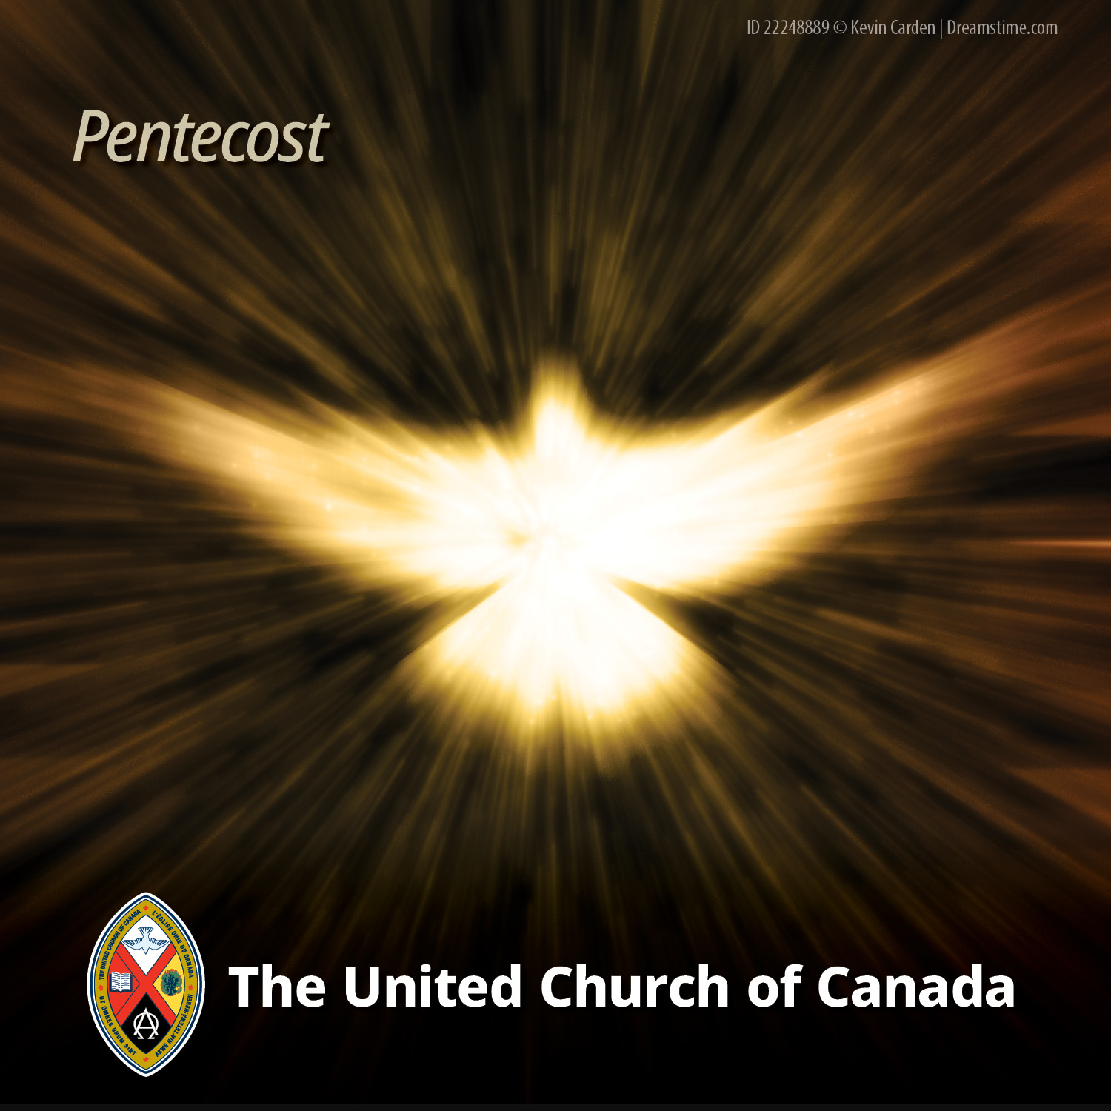

A gift of belonging to a church is that the practice of gathering together for worship … to pray, sing, listen to scripture and share how God touches our lives – helps us grow in deeper relationship with God and each other. We are offering this practice of sharing beyond Sunday morning to deepen our connection. Each week you are offered a picture, a scripture and a question for contemplation, as well as a short reflection for you to contemplate, have conversation with people in your life and/or join an online conversation on our Rockwood Stone Facebook page.

