
Contemplation and Conversation: 7th Sunday of Easter, May 17, 2026
Scripture – 1 Peter 4:12-14, 5:6-11 NRSVUE
¹² Beloved, do not be surprised at the fiery ordeal that is taking place among you to test you, as though something strange were happening to you. ¹³ But rejoice insofar as you are sharing Christ’s sufferings, so that you may also be glad and shout for joy when his glory is revealed. ¹⁴ If you are reviled for the name of Christ, you are blessed, because the spirit of glory, which is the Spirit of God, is resting on you.
⁶ Humble yourselves, therefore, under the mighty hand of God, so that he may exalt you in due time. ⁷ Cast all your anxiety on him, because he cares for you. ⁸ Discipline yourselves; keep alert. Like a roaring lion your adversary the devil prowls around, looking for someone to devour. ⁹ Resist him, steadfast in your faith, for you know that your brothers and sisters in all the world are undergoing the same kinds of suffering. ¹⁰ And after you have suffered for a little while, the God of all grace, who has called you to his eternal glory in Christ, will himself restore, support, strengthen, and establish you. ¹¹ To him be the power forever and ever. Amen.
From Rev. Heather Leffler
These words from 1 Peter remind me that following Jesus has never meant a life free from struggle or sorrow. We live in a world where pain, grief, injustice and fear are real. At some point in our lives, all of us will suffer. Yet our faith reminds us that suffering is never faced alone. God does not abandon us in hardship. In Jesus, God entered fully into human suffering and walks beside us through it still.
When we remember Jesus’ suffering and resurrection, we are reminded that pain and death never have the final word. God can bring healing, courage, compassion and new life even in the midst of difficult experiences. Sometimes, after illness, grief, loss or disappointment, we discover a deeper compassion for others. Sometimes we gain a new appreciation for moments of joy, relationships, or the beauty of creation. Sometimes healing comes slowly, through the care and presence of others.
Our church family can be a significant part of this journey. A community that prays with us, supports us in grief, and celebrates moments of hope and joy reminds us that we belong to one another and to God. Together we are strengthened to care for our neighbours and to live with hope in challenging times.
Peter invites us to face life with humility and trust, remembering that Christ’s Spirit rests with us and that God’s grace continues to restore, support, strengthen and establish us.
Contemplation and Conversation
When have you experienced God’s presence or the support of others during a difficult time?
Prayer
Risen Christ, help us face life’s challenges with humility and trust.
Restore us, support us, strengthen us and hold us in your loving presence. Amen.
Further Conversation … Would you like to talk more about today’s reflection? Email Heather at hleffler@rogers.com.

Our Rockwood Stone Family
If you missed today’s worship service, you can watch it here: https://youtu.be/ZEjYnis40wA
Check the attachments for the Spring Newsletter.
Please note that the Celebration of Life for Marg Cox and Linda Willis is Saturday, May 30, 2026 from 1 to 4 pm at Rockmosa Community Centre.

From the Rockwood Stone Board
We want to update you that we have been in touch with staff from Western Ontario Waterways Regional Council about the process of searching for a new minister. Briefly, the process ahead will involve the Board appointing a supply minister for 6 months hopefully beginning October 1st, 2026. Laurie Stevenson, Minister Pastoral Support is our contact person for this process, and a liaison person will be appointed to support us.
Our Profile team has completed our community of faith profile. We are grateful for everyone’s input as we work to tell the story of our churches. The Board as our governing body approved the profile at our meeting on May 13th. The Profile information has been shared for preliminary review by John Neff, the Congregational Support Minister.
The next step once its clear our Profiles information is complete and appropriate will be for a meeting of Rockwood and Stone to consider approving it. If approved, it will be posted on the United Church’s online pastoral relations tool, ChurchHub, for viewing by ministry personnel who are searching for a new pastoral charge. Initially we will be recruiting for a supply position for 6 months which can be extended up to 18 months. The Board appointed Rosslyn Bentley, Brian Mack, Tammy Smits and Sherol Steinberg to draft a position description for a supply minister.
The step after this will be to create a search team, and they will review profiles of ministry personnel, conduct interviews, check references, and eventually make a recommendation to a meeting of our whole faith community. Our goal is to select a minister whose gifts and skills are a good match with who we are as a church. Please pray for God’s spirit of discernment to be at work in our community and in our future minister.

United Church of Canada
May 17 is International Day Against Homophobia, Biphobia, and Transphobia. Join us today in support of the non-negotiable truth of every person’s dignity.
Creator, we come to you with both the joys and the sorrows of our hearts.
We are grateful for the gift of life and the joy that it can bring.
For families and friends who love us.
For allies who stick up for us, even when we cannot risk sticking up for ourselves.
For the great diversity you have created in our world.
We pray for those who suffer from discrimination because of their gender identity or sexual orientation.
Who worry about their employment or who cannot find a job.
For those who must hide who they are to find housing.
For those who are not safe on our streets.
For those who do not feel safe in their place of worship.
Help us to end homophobia, transphobia, and biphobia, and all forms of discrimination and hate.
Show us the way to make this world a better place for all.
—written by Ruth Wood, for The United Church of Canada and Affirm United/S’affirmer Ensemble (2017).
#UCCan #IDAHOBIT #2SLGBTQIA #HumanRights
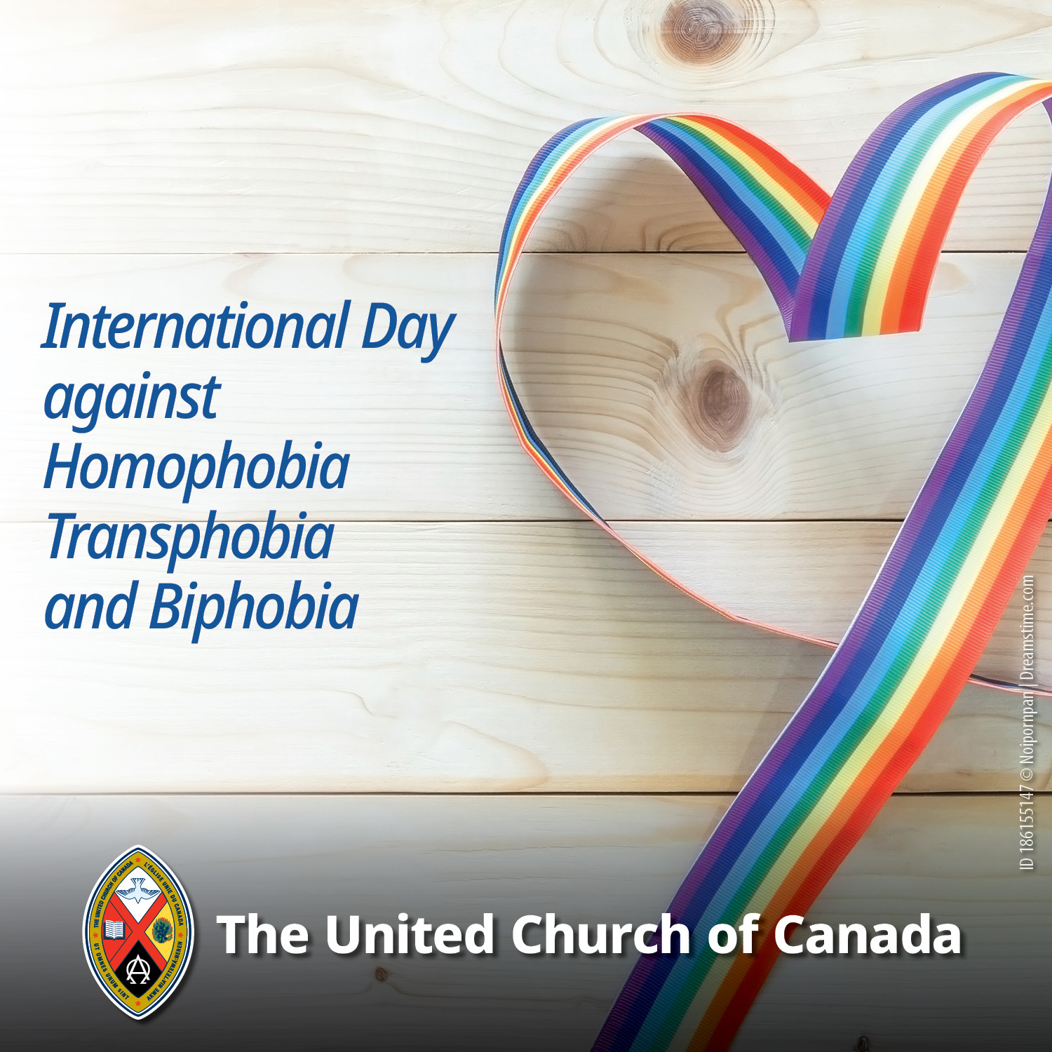

A gift of belonging to a church is that the practice of gathering together for worship … to pray, sing, listen to scripture and share how God touches our lives – helps us grow in deeper relationship with God and each other. We are offering this practice of sharing beyond Sunday morning to deepen our connection. Each week you are offered a picture, a scripture and a question for contemplation, as well as a short reflection for you to contemplate, have conversation with people in your life and/or join an online conversation on our Rockwood Stone Facebook page.

