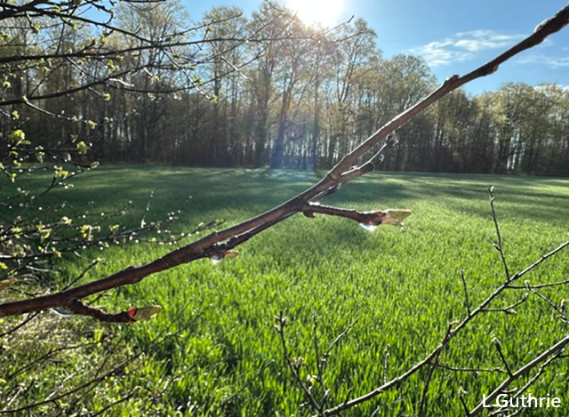
Contemplation and Conversation
6th Sunday of Easter, May 10, 2026
Scripture – John 14:15-21 NRSVUE
¹⁵ “If you love me, you will keep my commandments. ¹⁶ And I will ask the Father, and he will give you another Advocate, to be with you forever. ¹⁷ This is the Spirit of truth, whom the world cannot receive because it neither sees him nor knows him. You know him because he abides with you, and he will be in you.¹⁸ “I will not leave you orphaned; I am coming to you. ¹⁹ In a little while the world will no longer see me, but you will see me; because I live, you also will live. ²⁰ On that day you will know that I am in my Father, and you in me, and I in you. ²¹ They who have my commandments and keep them are those who love me, and those who love me will be loved by my Father, and I will love them and reveal myself to them.”
From Rev. Heather Leffler
In life, in death, in life beyond death, we are not alone. We offer this phrase from our United Church New Creed to give comfort and hope. It is grounded in Jesus’ words to the disciples at the Last Supper.
God is not an indifferent deity who set creation into motion and sat back to watch what unfolded. The Holy One is not out there watching and waiting to judge or condemn us.
The One we call Father and Mother is lovingly engaged in our everyday lives. Throughout history, God sent angels, priests, judges, kings and prophets to invite people into loving relationship with God and one another. Then, in self-giving God came as a babe in the manger to live among us. In his life, Jesus fed the hungry, healed the sick, embraced the people on the margins and challenged unloving behaviour. As he prepared his disciples for his death, he reminded them – and reminds us – that he was God incarnate – fully human, love made flesh.
God was in Jesus. After his resurrection, Jesus sent the Spirit to guide, comfort and advocate for us. The Spirit is in us – praying through us when we can’t find the words, guiding us to make loving choices for ourselves and the people, creatures and creation around us. Through prayer and conversation with others, the Spirit helps us discern how to live in the world as bearers of God’s love. May it be so.
Contemplation and Conversation
How do you experience the Spirit’s presence?
Prayer
Holy Mystery, you are Wholly Love.
Thank you for the assurance that you are always with us.
Help us be guided by your Spirit in all we think, say and do. Amen.

Further Conversation … Would you like to talk more about today’s reflection? Email Heather at hleffler@rogers.com.

Our Rockwood Stone Family
If you missed today’s worship service, you can watch it here: https://youtu.be/OAg9F3qlWj4 .

**NOTE: Time change for the Board Meeting on Wednesday, May 13, 2026. New time for gathering is 7:00 pm.

United Church of Canada – Following last year’s nationwide campaign of welcome and service, we invite communities to bring their picnic tables back out to the street
Published On: May 5, 2026
Throughout summer and fall 2025, 100 Tables brought a new type of United Church presence to life in communities across the country. Congregations took to the streets, placing picnic tables outside their church doors that had been transformed into sites of welcome and service to their neighbours. It was a joyous nationwide celebration of The United Church of Canada’s 100th anniversary last June, and a Spirit-filled reflection of the church’s century-long commitment to live out God's call to love and serve.
As spring blooms and our centennial year draws to a close, we are excited to once again invite all United Church communities of faith to take part in 100 Tables!
New ideas for projects and favourites from last year are welcome, and we highly encourage both communities who participated in 2025 and those who couldn’t make it to join in the fun. Communities who haven’t yet received a $225 RONA gift card to purchase their picnic table are still eligible to do so. Participants from last year will receive more information in the coming weeks.
For project inspiration, take a look at the Map of 100 Tables, featuring stories and photos from churches who took part in 2025. Over 115 communities of faith ultimately participated in the initiative, from Vancouver’s Highlands United Church, all the way to Carbonear Pastoral Charge, Newfoundland.
Tables offered space for connection, and for congregations to articulate their understanding of Jesus’ invitation to the table. Communities engaged neighbours in conversations about food security, Truth and Reconciliation, and 2S and LGBTQIA+ pride, or offered a friendly face and a bite to eat. They also got their creative juices flowing: along with dozens of beautifully painted tables, the project inspired a new song, a board game, a mural, and much more.
If you’d like to discuss project concepts for your table, or have any questions about the initiative, our Growth team is here to help: get in touch at 100tables@united-church.ca.
We’re so excited to see the ways that churches continue to live out our tradition of service and invitation in their neighbourhoods, as we together imagine the future of what The United Church of Canada can be in the world.
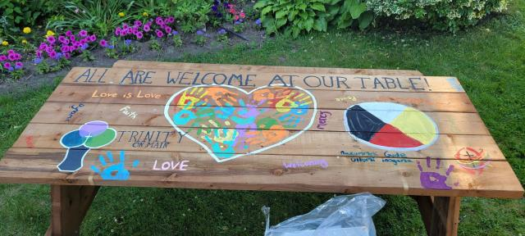
Trinity United Church, Newmarket, Ontario

A gift of belonging to a church is that the practice of gathering together for worship … to pray, sing, listen to scripture and share how God touches our lives – helps us grow in deeper relationship with God and each other. We are offering this practice of sharing beyond Sunday morning to deepen our connection. Each week you are offered a picture, a scripture and a question for contemplation, as well as a short reflection for you to contemplate, have conversation with people in your life and/or join an online conversation on our Rockwood Stone Facebook page.

