Contemplation and Conversation: Palm and Sunday, March 29, 2026
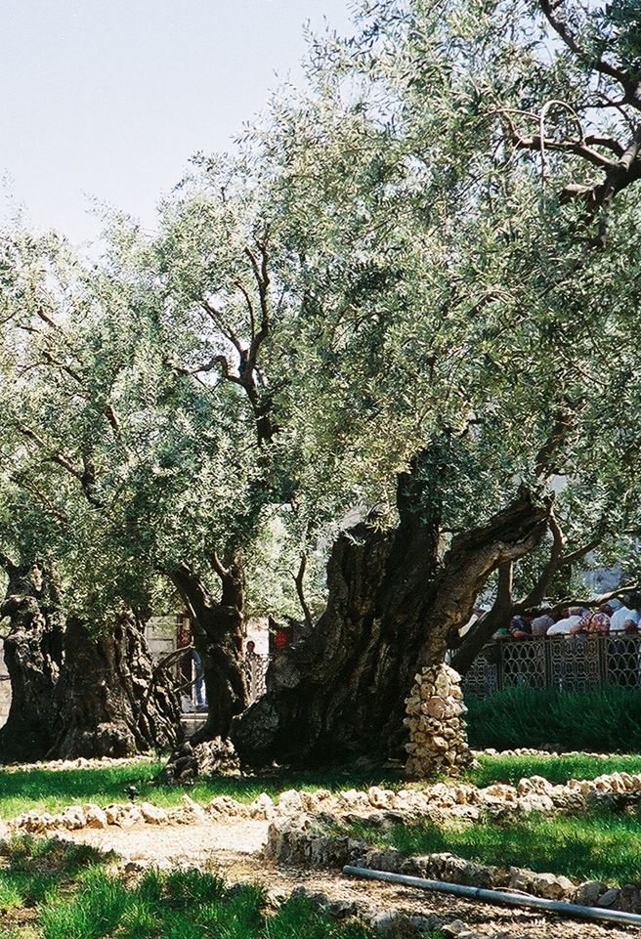
Scripture – Psalm 31:6-19 NRSVUE
⁹ Be gracious to me, O Lord, for I am in distress;
my eye wastes away from grief,
my soul and body also.
¹⁰ For my life is spent with sorrow
and my years with sighing;
my strength fails because of my misery,
and my bones waste away.
¹¹ I am the scorn of all my adversaries,
a horror to my neighbors,
an object of dread to my acquaintances;
those who see me in the street flee from me.
¹² I have passed out of mind like one who is dead;
I have become like a broken vessel.
¹³ For I hear the whispering of many—
terror all around!—
as they scheme together against me,
as they plot to take my life.
¹⁴ But I trust in you, O Lord;
I say, “You are my God.”
¹⁵ My times are in your hand;
deliver me from the hand of my enemies and persecutors.
¹⁶ Let your face shine upon your servant;
save me in your steadfast love.
From Rev. Heather Leffler
As we begin our journey through Holy Week, we remember Jesus’ entry into Jerusalem. We have followed him to the Upper Room, shared in communion, sung together, and walked with him to the garden of Gethsemane. Along the way, we see how Jesus prepares his disciples for what lies ahead. In John’s Gospel, he even kneels to wash their feet—offering both words and actions that call them to love and serve.
In the garden, we see something more. Jesus takes time to pray. Knowing that the authorities are searching for him, and that betrayal is near, he turns to God in his anguish.
The words of the psalm we heard today echo that same deep distress—fear, grief, isolation—and yet also a profound trust: “But I trust in you, O Lord… my times are in your hand.”
Jesus would have known these words. He would have prayed them, sung them, carried them within him. And perhaps, in that moment in the garden, they gave him language for his sorrow—and courage to entrust himself to God.
Scripture reminds us, again and again, that whatever we face—in life, in death, and in life beyond death—God is with us. The Holy One who was present with Jesus in the garden is present with us still: in our fear, in our grief, and in our moments of trust.
Contemplation and Conversation
When have the words of scripture—or the story of Jesus—
given you comfort, strength, or language for what you were feeling?
Prayer
Loving God, as we walk this Holy Week journey,
remind us that you are with us—in our sorrow and in our joy.
Help us to trust you, and to follow the way of Jesus. Amen.

Further Conversation … Would you like to talk more about today’s reflection? Email Heather at hleffler@rogers.com.

Our Rockwood Stone Family
If you missed today’s worship service, you can watch it here: https://youtu.be/pFYjmi8q2M4

Looking ahead …
April 19 Lisa Leffler will lead worship in both churches while Heather is on study leave.
May 24 at 10 am at Stone the Worship and Faith Formation Committee will lead a combined service.
June 7 at 10 am at Rockwood we will celebrate Rockwood’s Anniversary and share lunch.
June 28 at 10 am we will begin our worship at Stone and move to Rockwood to continue worship and share a potluck lunch for Heather’s final service with us.

United Church of Canada Published March 17, 2026
Moderator Kimberly Heath invites us to plan how we will celebrate Earth Week 2026, April 19-26. Watch her invitation or go to Together for the Love of Creation Earth Week 2026 to learn more.

A gift of belonging to a church is that the practice of gathering together for worship … to pray, sing, listen to scripture and share how God touches our lives – helps us grow in deeper relationship with God and each other. We are offering this practice of sharing beyond Sunday morning to deepen our connection. Each week you are offered a picture, a scripture and a question for contemplation, as well as a short reflection for you to contemplate, have conversation with people in your life and/or join an online conversation on our Rockwood Stone Facebook page.

