
Contemplation and Conversation: Transfiguration Sunday, February 15, 2026
Scripture – 2 Peter 1:16-21 NRSVUE
¹⁶ For we did not follow cleverly devised myths when we made known to you the power and coming of our Lord Jesus Christ, but we had been eyewitnesses of his majesty. ¹⁷ For he received honor and glory from God the Father when that voice was conveyed to him by the Majestic Glory, saying, “This is my Son, my Beloved, with whom I am well pleased.” ¹⁸ We ourselves heard this voice come from heaven, while we were with him on the holy mountain.
¹⁹ So we have the prophetic message more fully confirmed. You will do well to be attentive to this as to a lamp shining in a dark place, until the day dawns and the morning star rises in your hearts. ²⁰ First of all you must understand this, that no prophecy of scripture is a matter of one’s own interpretation, ²¹ because no prophecy ever came by human will, but men and women moved by the Holy Spirit spoke from God.
From Rev. Heather Leffler
Each year on the Sunday before Lent, we read the Transfiguration story from one of the gospels – Matthew, Mark or Luke. This year in our epistle reading we hear Peter’s first had account of what happened that day – what he, James and John heard and saw on that mountain. Peter is clear – this was no cleverly devised story. He is bearing witness to something he saw and heard with his own eyes and ears. He saw Jesus transfigured before his eyes and heard God say Jesus is his beloved son.
Peter – who left his fishing boat and family to follow Jesus, walked on water and faltered, declared Jesus the Messiah and then rebuked Jesus when Jesus said he had to go to Jerusalem and the cross, who with Paul and the other apostles founded the Christian Church – assures us that the Holy Spirit is with us whatever is happening in our lives, our churches and the world.
Peter experienced firsthand the voice of God, the presence of Jesus and the guidance of the Holy Spirit. That one and the same Lord has called us to be the church and invites us to listen and be guided by the Spirit in our personal lives and as community. Peter shares his testimony so that even in dark places his witness will be a lamp assuring us of the Holy One’s presence in our lives. He offers his testimony like a lamp in a dark place – not to blind us with certainty, but to give just enough light for the next faithful step.
As you gather for focus groups, you are not simply planning programs or imagining possibilities. You are listening – for the same Spirit who moved prophets, who spoke on the mountain, and who continues to guide the church. Discernment is less about finding the perfect strategy and more about paying attention to where the light is already shining among us.
This week as you engage the questions offered for the focus groups you are invited to listen for God speaking to you and through you and others – trusting that the voice Peter, James and John heard still speaks to us.
Contemplation and Conversation
When have you experienced God’s presence in your life or in our church –
and how might that experience guide us as we look to the future?
Prayer
God of mountaintops and crosses, thank you for Peter’s witness
that reminds us your light still shines in dark places.
When the way forward feels uncertain, be our lamp and our morning star.
Open our ears to hear your Spirit, and shape us into the church
you are calling us to be in this time and space. Amen.

Further Conversation … Would you like to talk more about today’s reflection? Email Heather at hleffler@rogers.com.

Our Rockwood Stone Family
If you missed today’s worship service, you can watch it here: https://youtu.be/KHVNPrrYsE8
Rockwood Stone Focus Groups
In preparation for the in person Focus Groups on Saturday, February 21st at 1pm at Stone and at 3 pm at Rockwood at each church or at 7 pm on Monday, February 23rd on Zoom, we had agreed to send out the questions ahead of time for you to consider. We also suggest that to really lift the process into an intentional place as churches that you include a spiritual practice ahead of our meeting and purposefully bring God into your thinking about these questions.
- What attracts you to our church and what do you value most?
- Where do you consider we are as a congregation right now?
- What do you consider to be our strengths and weaknesses and why?
- Where do we want our churches to be in 5 years? 10 years?
- What ideas do you have about how we might reach these goals?
- What do our congregations look like from viewpoints we haven't yet considered?
- Are there any scenarios or circumstances that you consider to be absolutely not suitable for the congregation?
Thank you. Please feel free to engage other people in the process both from our congregation, your families, friends and the community so we get a broad perspective reflected in the responses.
We look forward to seeing and hearing from as many people as possible.
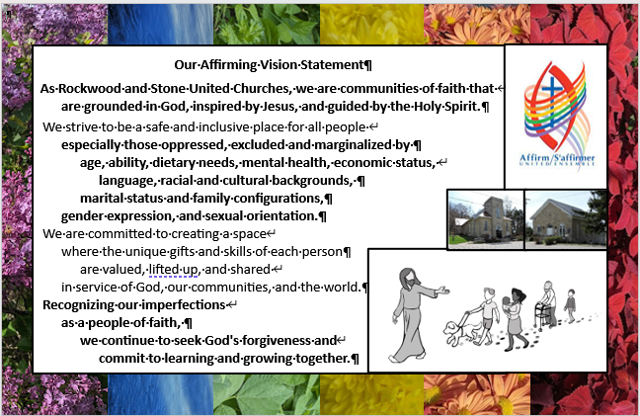
Bill, Liz, Barb and Rosslyn

United Church of Canada – Kitchen Conversations
Join us this Lent for Kitchen Conversations with the Moderator, a six-part video series exploring faith, food, and the power of invitation, hosted by The Right Rev. Dr. Kimberly Heath.
Drawing inspiration and recipes from the United Church’s Lenten devotional, Bless Break Share: Recipes for Faithful Living, we’re getting in the kitchen with guests from across the church, including book contributors, United Church youth, and the Moderator’s own family.
Starting Shrove Tuesday, we’ll be breaking bread at a church each week throughout Lent, reflecting on how food can nourish both body and soul, and how in joining around the table, we connect to something deeper than ourselves.
Join the Conversation
Bless Break Share, along with a matching mug and apron, is available to order or download on UCRDstore.
Want to dig deeper into Bless Break Share? You can also join Rev. Dr. Christine Jerrett for a six-week online Lenten study of the devotional on CHURCHx, beginning February 24. Signing up gets you a discount code for 15% off your purchase of Bless Break Share. 20% discounts are also available on bulk orders of the book.
Print and post the recipe cards, available in the Downloads below. These can be used in your own kitchen, as a Lenten reminder, or you can share them with friends and family. Churches can include them in worship bulletins or use them at fellowship meals.
Have a story to share? Send your reflections on food and faith, or a photo of your take on one of our Kitchen Conversations dishes, to kitchenconversations@united-church.ca.
Tune in as we embody the gospel of welcome, and continue to create A Place at the Table for all.

A gift of belonging to a church is that the practice of gathering together for worship … to pray, sing, listen to scripture and share how God touches our lives – helps us grow in deeper relationship with God and each other. We are offering this practice of sharing beyond Sunday morning to deepen our connection. Each week you are offered a picture, a scripture and a question for contemplation, as well as a short reflection for you to contemplate, have conversation with people in your life and/or join an online conversation on our Rockwood Stone Facebook page.

